

**LORAWAN PROJECT**

By:

Devomech Solutions Pvt. Ltd.

Date: 31-03-2023

# Current Progress:

* Lora/RFM Long Range Transceiver Shield 915 user the Rfm95 board for radio communication. The rfm95 board is a wide range board which works in 2 bands

1. 433MHz in Asia
2. 868 MHz or 915 MHz in Europe and America

* Both band are free and are called ISM (industrial, scientific and medical) band.

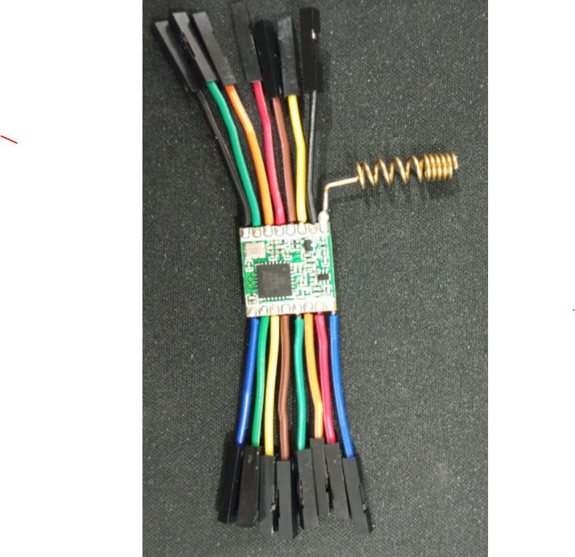

Figure 1 RFM 95 module

* The RFM95 supports different modes of operation, including point-to-point, point-to-multipoint, and mesh networking. In point-to-point mode, two nodes communicate directly with each other, while in point-to-multipoint mode, one node broadcasts a message to multiple nodes.
* During high rate of data transmission in multiple nodes RFM95 can sometime results in packet collision, but in our case latency is not an issue during transmission due to which a durable multiple node communication can be established using delays between signals.
* The Module has a theoretical range of 2KM which can vary in different fields or obstacles.
* Lora module has max output power of 20 dBm and we can also use Lora module as a signal repeater to increase the range of communication.

# Task for Next Week

* Test the code for one way aswell as two way comunication between Lora transmitter and receiver.
* Write a code for multiple nodes comunication.